

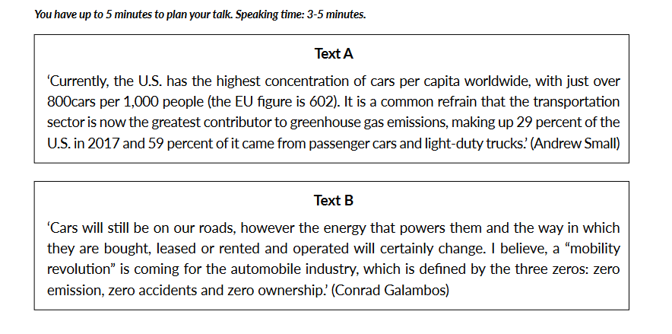

Our world is developing. And cars too. Is it good or not? I have read both materials. Both materials raise an issue of using cars.

To start with, I`d like to pay an attention to the first text. There is an opinion that the U.S. has the highes concentration of cars per capita worldlife. 800 cars per 1.000 people. And the precent of emissions has gone up. The second text explains that the people belive a “mobility revolution” will be.

My first argument would be that we need more walk and more ride on the bicycle. Because we would save our nature and futhure. My second argument would be that we need to come up a new fuel witch don’t have bad effect.

I agree with the texts. To my mind, we can’t delete the cars from our life. Because car is very comfortable kind of movement. A lot of people are traveling, or just ride to the work. We have a very big world. The very big distance between cities and countries. That we need a fast kind of movement like a car. So, In my opinion we need cars. But, we need to come up a new fuel. If we find a replacement than the gas emission has gone down.

To conclude, We need to more walk and find a new kind of fuel.